**BUILD A SERVERLESS CI/CD PIPELINE ON AWS WITH ECR**

**STEPS:**1. Launch an EC2 Instance, and then login to it   
2. Install Docker and Git. 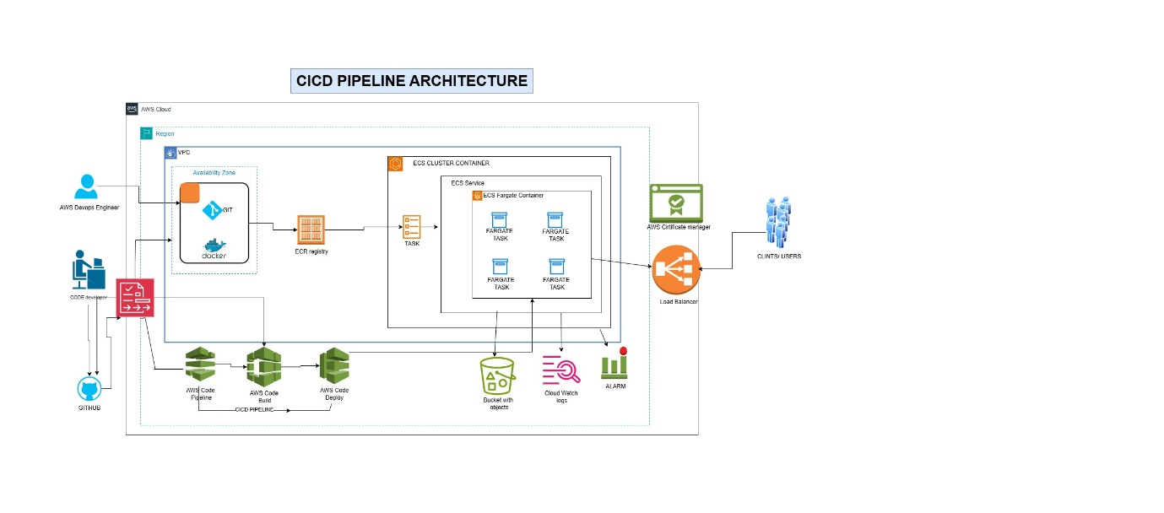

3. Store the Application Readily in the GitHub Repository. Which is developed by Developers

4. Using this GitHub clone it into the machine Launched.

5. Now create an image of the system state which has the application.

Now understand the below image how we normally move forward

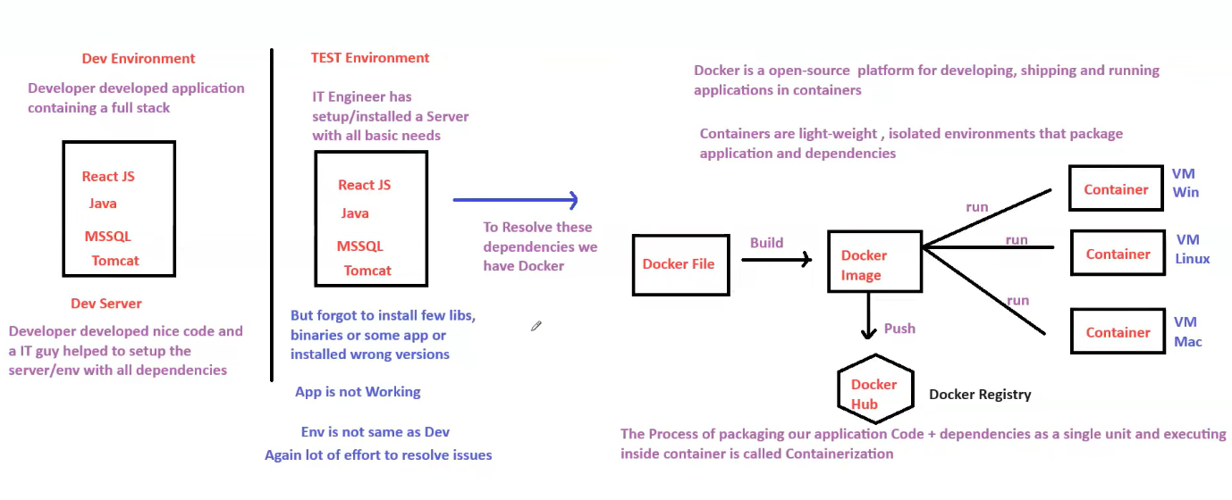

* Here as in the steps after Docker image is Created it is pushed to into Docker hub for future use, and then we create container based on the application on our machines.
* But we are creating ECR and ECS in our project instead of creating containers.

6. Using Docker file we Create an image and that image we set in the ECR registry.

7. From this ECR create an ECS Cluster, while creating cluster create a Task directory because ECS will create containers in the Fargate Further (This container needs the information how it should look like, its readied from task directory.)

8. As the clients/ Customers can’t access it through IP address, so for this we will create a service and it will be attached to a load balancer. As this should be very secure we attach an AWS certificate HTTPS.

9. All the logs and errors will be watched out and be stored in the S3 bucket and cloud watch logs, and create an Alarms for the load balancer to control the traffic coming.

10. Using Route 53 Service we can add a beautiful name to our Application.

11. This entire pipeline will be automated using AWS code Pipeline Service.